****Wireframe Documentation****

****Deloitte Case Study****

**Homepage**

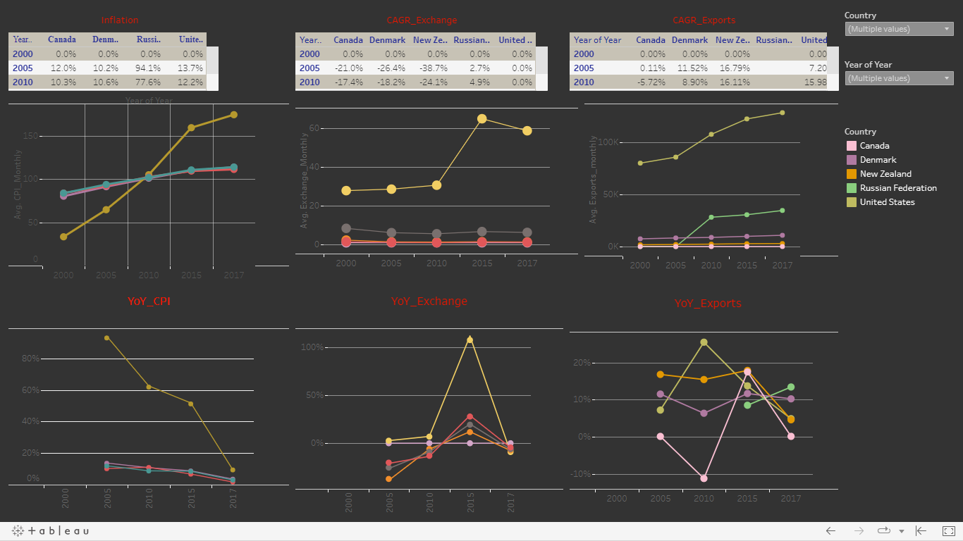

This is our dashboard design

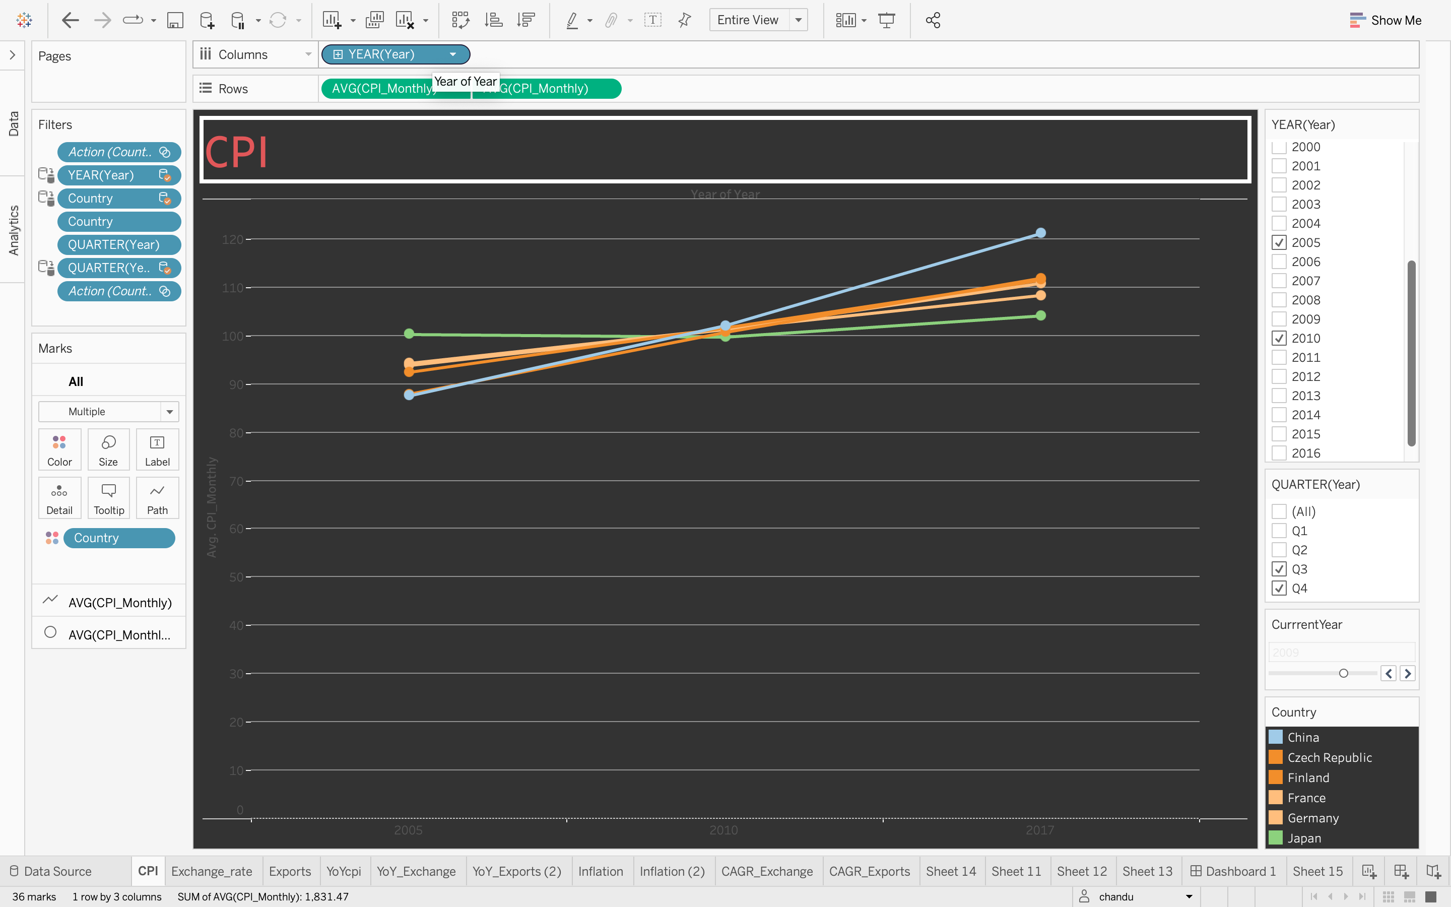

This is the cpi of every country from the year 1950 to 2017

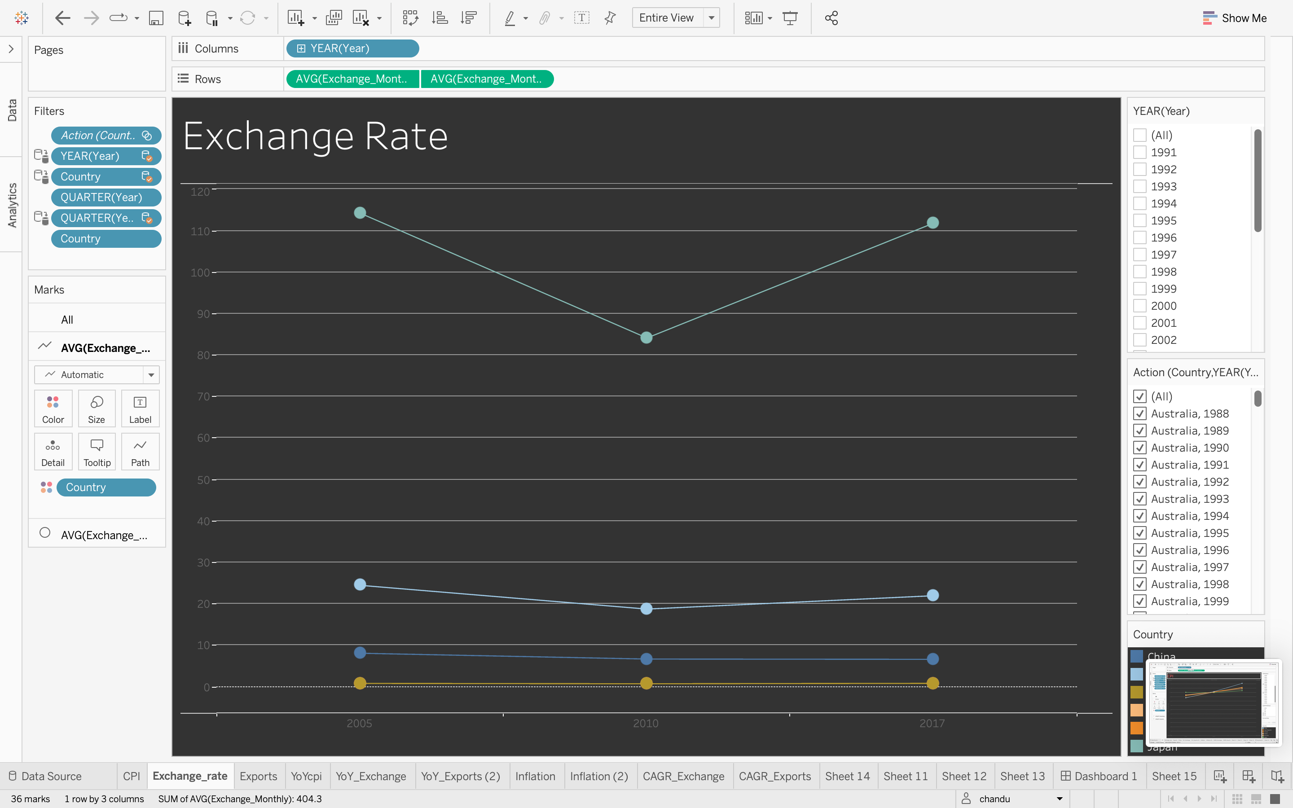

This is the Exchange rate of every country from the year 1950 to 2017

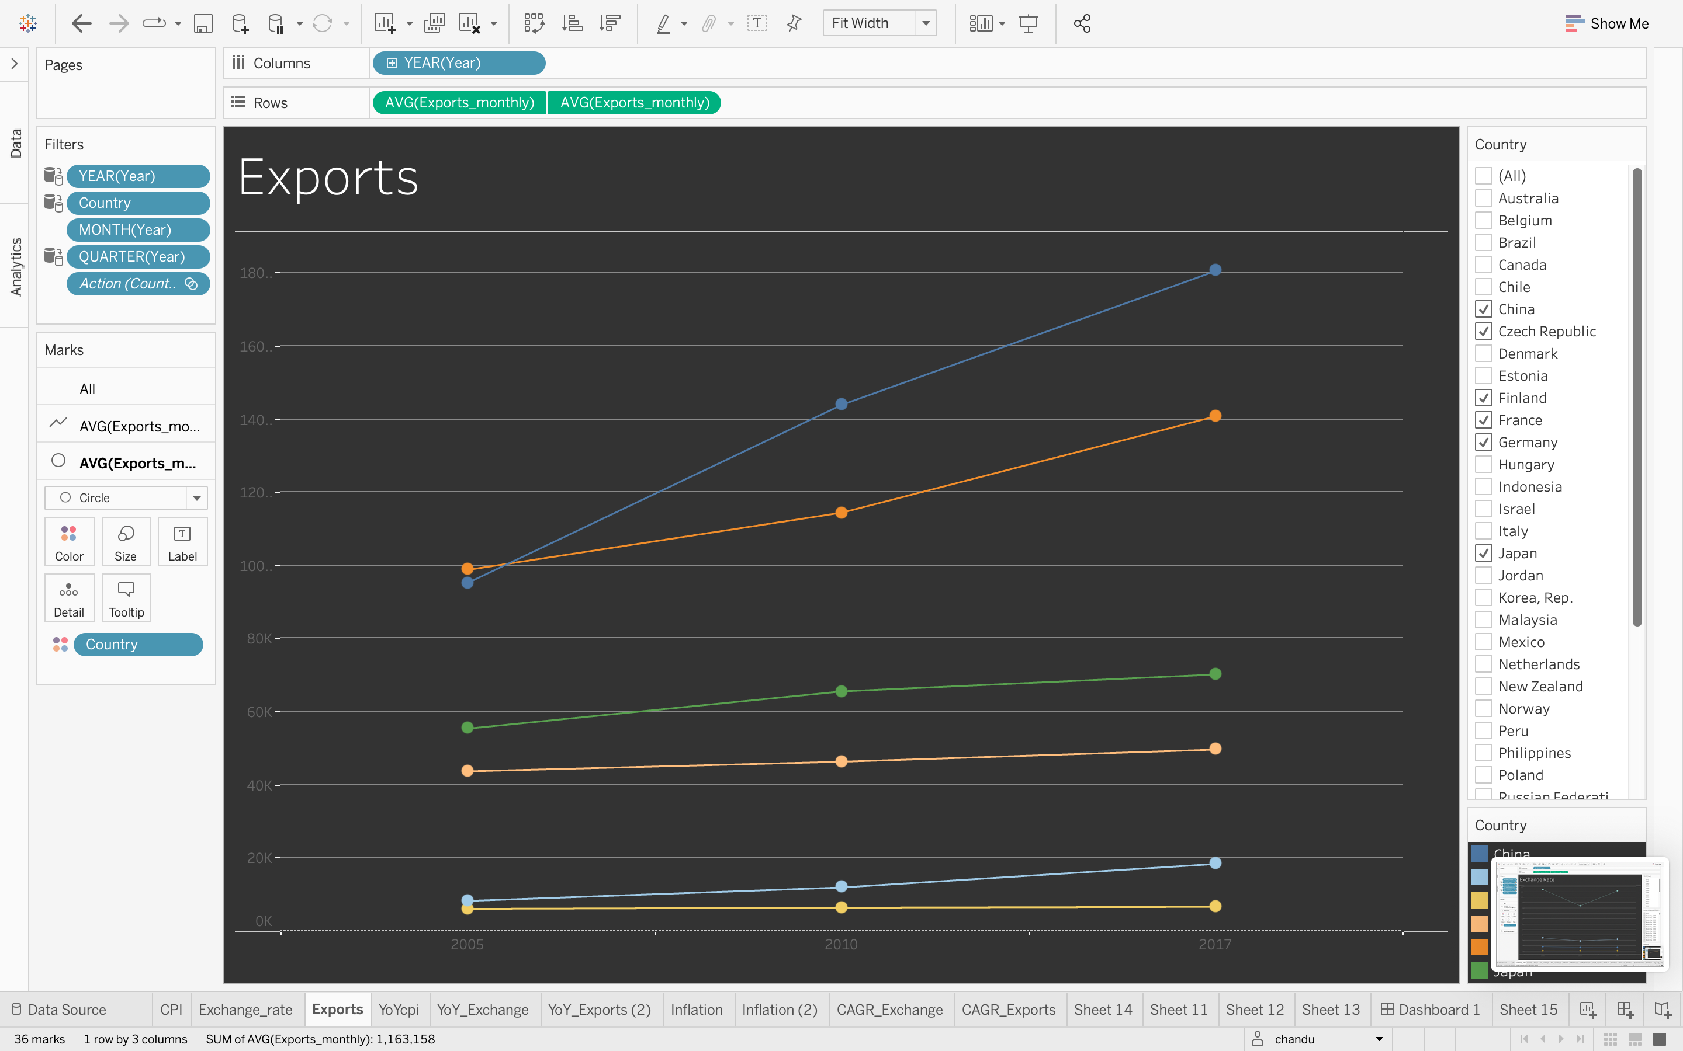

This is the Exports of every country from the year 1950 to 2017

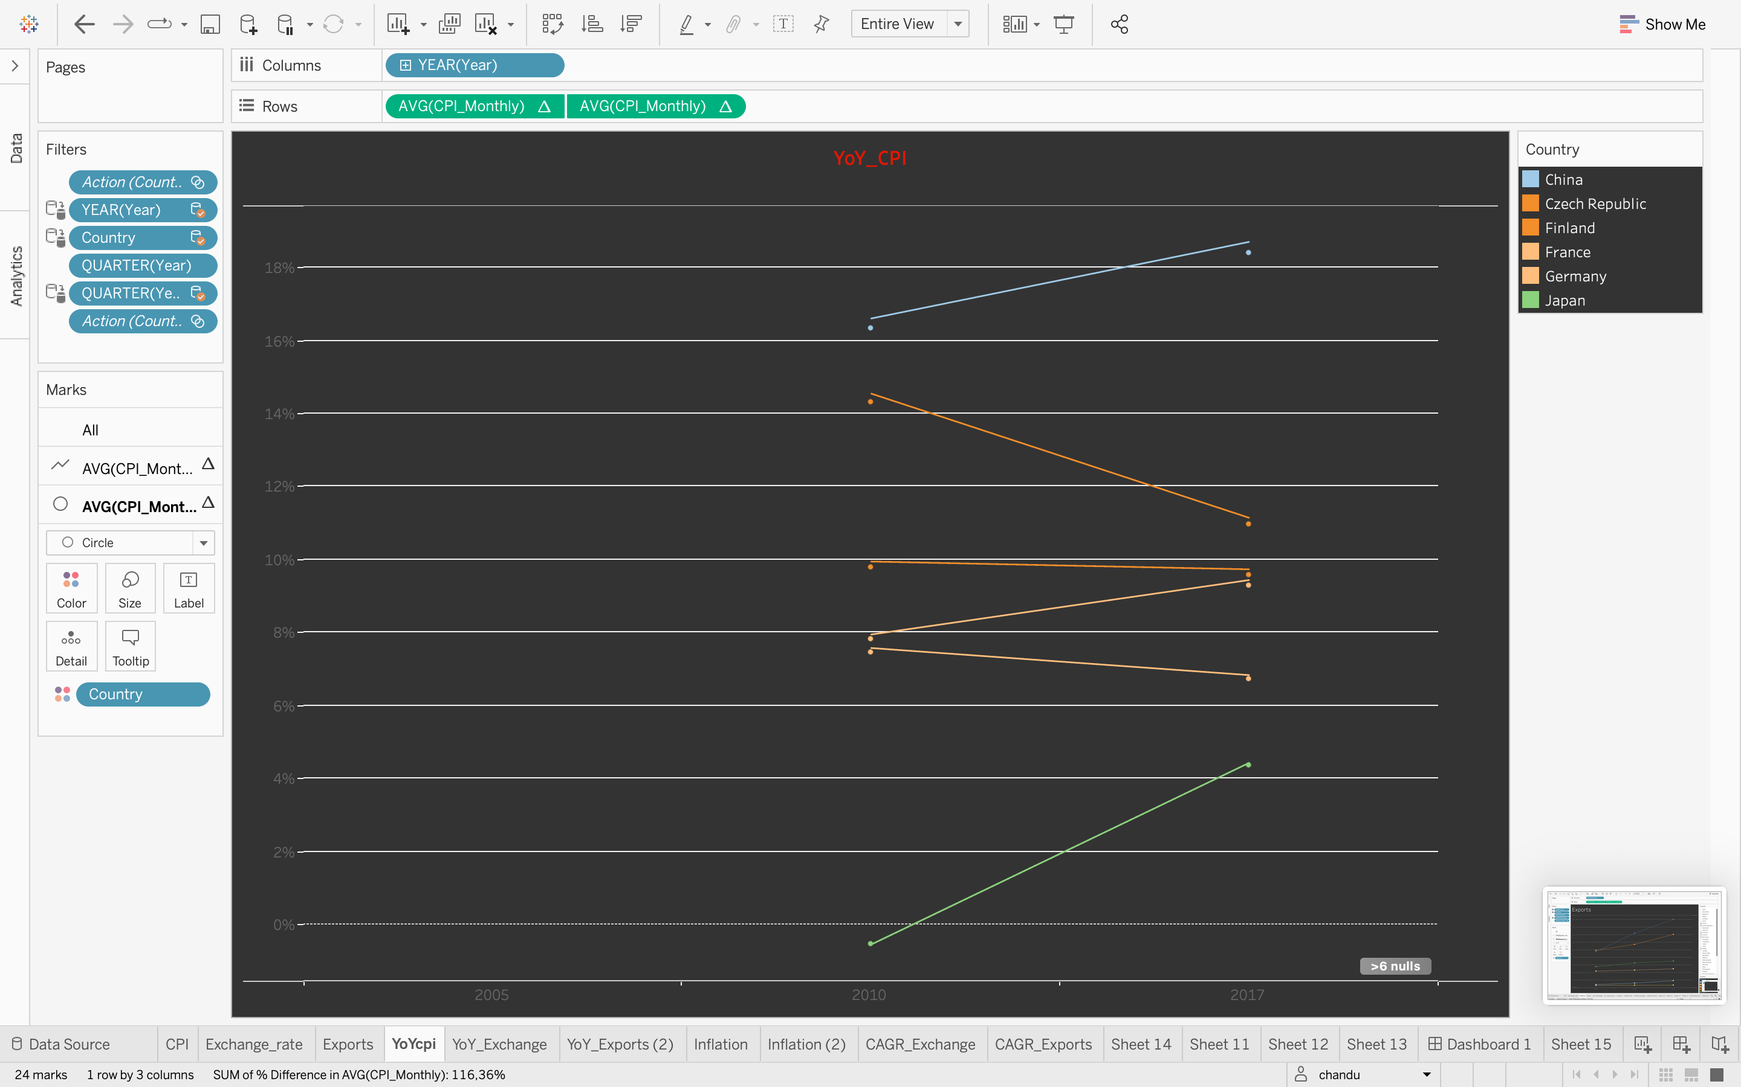

This is the YoY of CPI which explains us about INFLATION

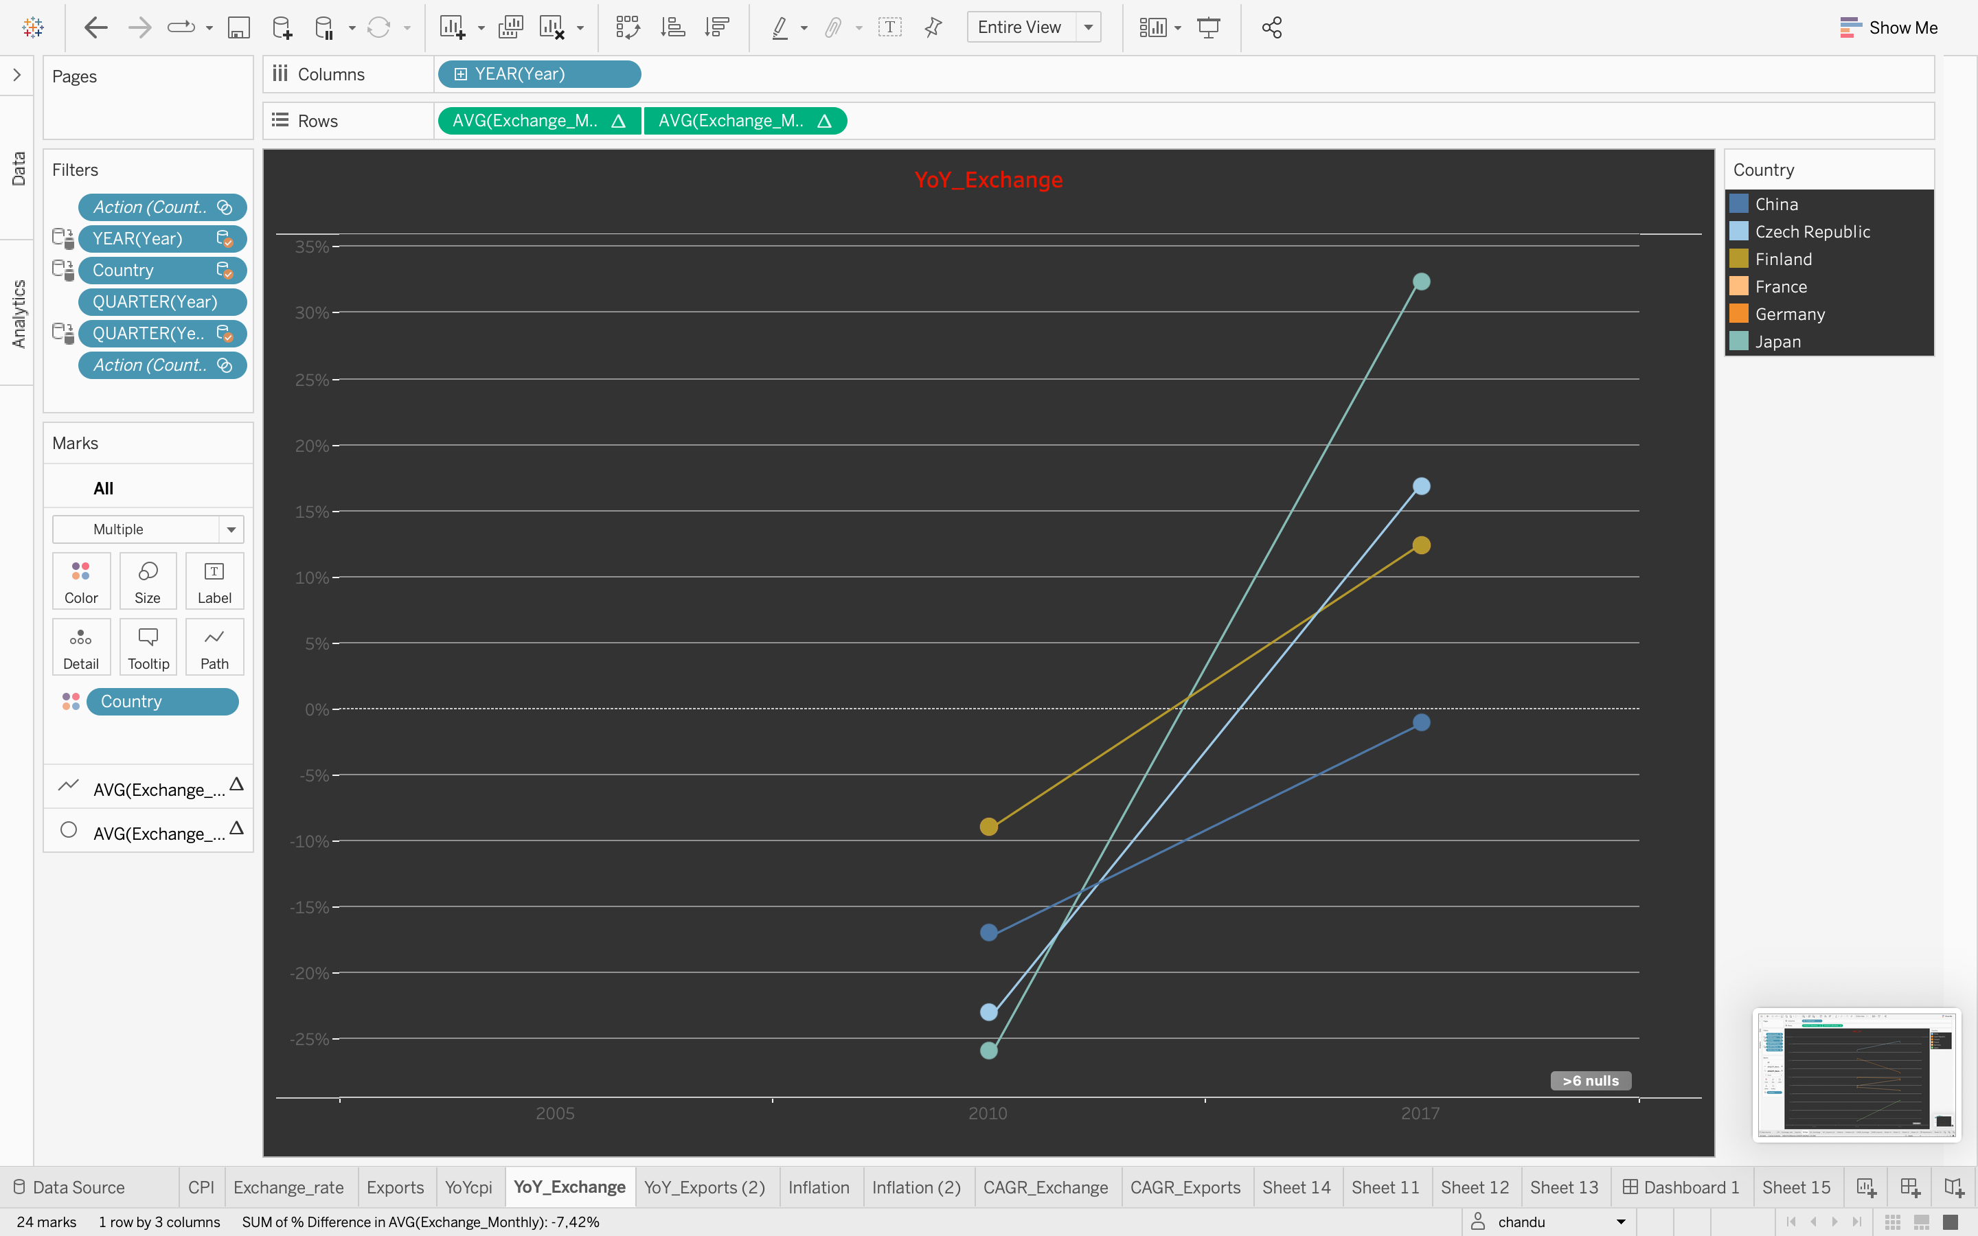

This is the YoY of Exchange Rate which explains us about INFLATION

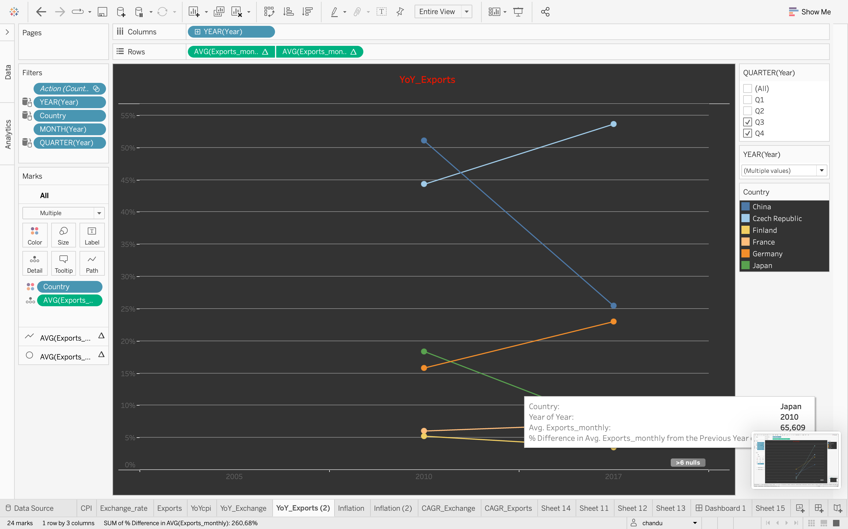

This is the YoY of Exports which explains us about INFLATION

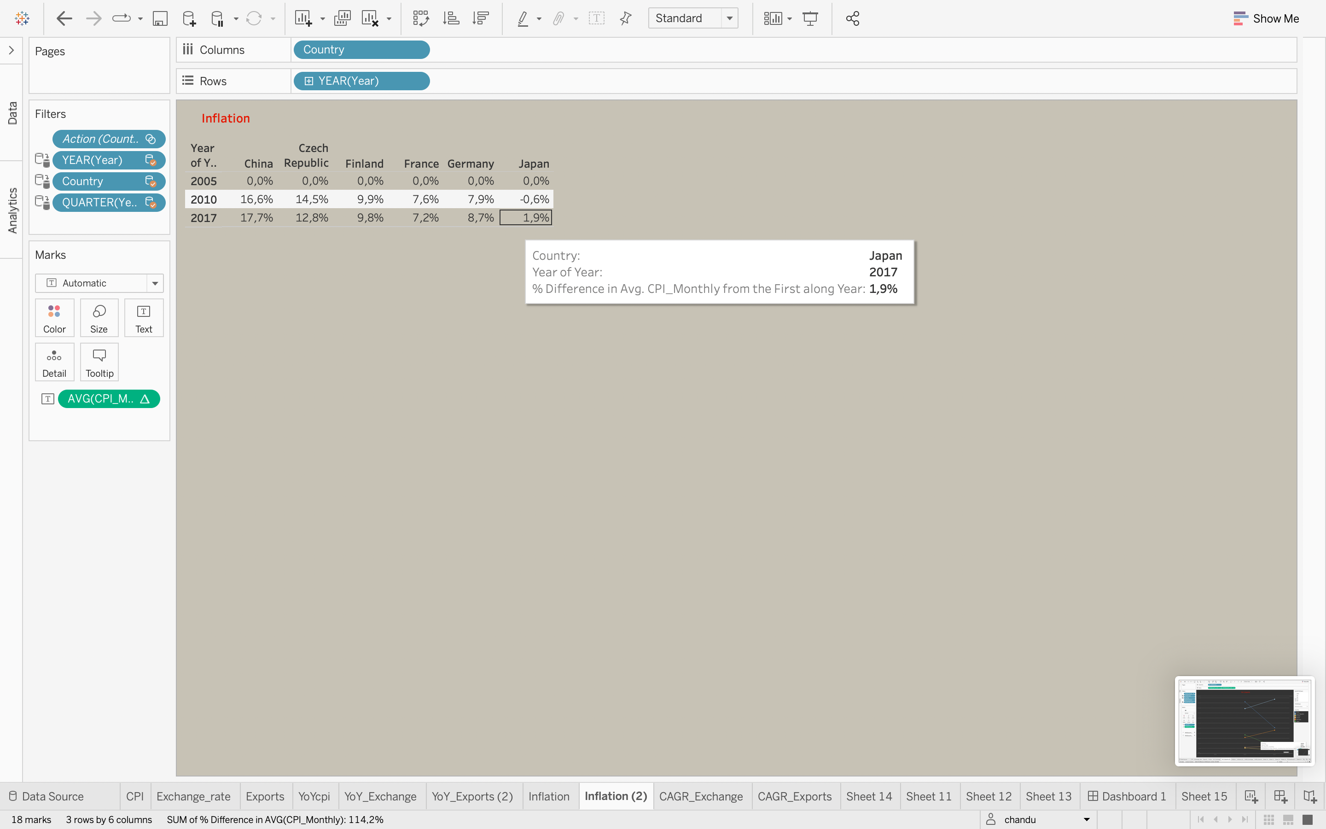

This is the Inflation rate of every country

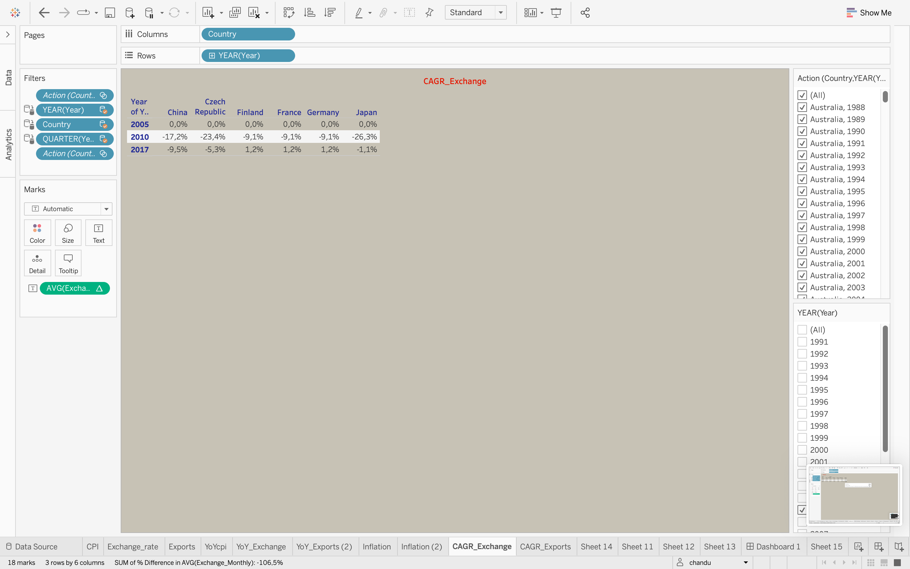

This is the CAGR exchange rate of every country

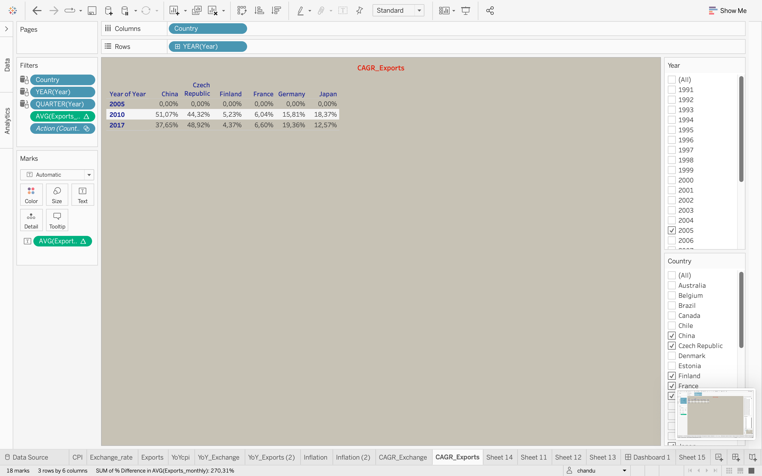

This is the CAGR exports of every country